Data Item | Contents
Title | The Restex Company
Tracking # | ??????????????????
Framework | Aria27
Specification Category | Custom Program
Specification Type | Custom Program
Standard | No
Customer | Restex
Date Created | 02/25/2005
Author | Taher
Date Edited
Editor

Section | Include | Last Editing Information
Vision | Yes
Stakeholder Names | Yes
Needs
Customer Functional Needs | Yes
Customer Technical Needs | Yes
ARIA Functional Needs | Yes/No | Date of editing and author’s name
ARIA Technical Needs | Yes/No | Date of editing and author’s name
ARIA Testing Needs | Yes/No | Date of editing and author’s name
ARIA Marketing Needs | Yes/No | Date of editing and author’s name
ARIA Documentation Needs | Yes/No | Date of editing and author’s name
ARIA Supplementary Needs | Yes/No | Date of editing and author’s name
Scope of the project | Yes/No | Date of editing and author’s name
Assumptions | Yes/No | Date of editing and author’s name
Glossary | Yes/No | Date of editing and author’s name
Required entities summary | Yes/No | Date of editing and author’s name
Required entities details | Yes/No | Date of editing and author’s name

Vision

Our client Restex needs to make the date entry process when doing a Material Invoice as easy as possible. Their entire inventory is kept by roll and users have to do a lot of calculations and actions to select and manage roll ids when doing invoices.

Stakeholder Names:
- Restex Management.
Management is intreasted in a quick and easy solution to the problem without having to complicate the programing as much as possible. The most important thing for managemnt is to speed data entry.
- Restex Users.
Users are intreasted in the data entry steps that they will have to do in order to ship an invoice. They usually ship a lot of rolls on the same invoice and do not want to keep entring qty for each roll manually.

Needs

Customer Functional Needs
- Restex needs to ease the data entry process by letting the system apply -as a default- the full qty of each roll shipped instead of forcing the user to type the qty applied every time he/she selects a new roll.
In other words, Restex needs the system to use the total qty of the roll as the default for the “applied qty” every time the user selects a new roll to apply.
Customer Technical Needs

Scope of Project
The project will be performed in one step only. The step will be related to one change on the “Invoice Material Sales Order” program.

Required Entities Summary
Entity # | Required entity title | Need(s) satisfied | Tracking #
1 | Change on the “Invoice Material Sales Order” Program | CFN1 | ???????

Required Entities Details and Features
Data Item | Include Status | Contents
Entity # | N/A | 1
Name | N/A | Change on the “Invoice Material Sales Order” Program
Type | N/A | Custom Program
Module(s) | N/A | MA
Tracking # | N/A | ????????
Features | Yes
UI | Yes
UI rules | Yes
Database design | No
Testing cases | No
Needs satisfied | N/A | CFN1
* NA: not applicable

Features
- Change to on the “Roll” screen the “Invoice Material Sales Order” Program to default the “Apply Qty” field with the value in the “Roll Balance” column.
  - When the user open the screen for the first time, the system should default the “Apply Qty” filed with the value of the first roll automatically.
  - Since that the first roll might not be enough to cover the sold qty on the Fabric/color line, the user will need to choose other rolld to cover it. The system should default “Apply Qty” with the roll value on each roll line the user highlights with the mouse.
  - Every time the user clicks on a roll line, the system automatically update the “Apply Qty” with the roll value.
  - All other features currently available on this screen (such as, not exceeding the total qty shipped) are still valid.
  - User should still have the ability to modify the “Apply Qty” field should he/she chooses to do so.
  - If the remaining qty to be applied is ess than the value of the last roll the user is clicking, the system should default the “Apply Qty” with the remainder of the qty not the roll value.

SOFTWARE DESIGN

User Interface (UI)
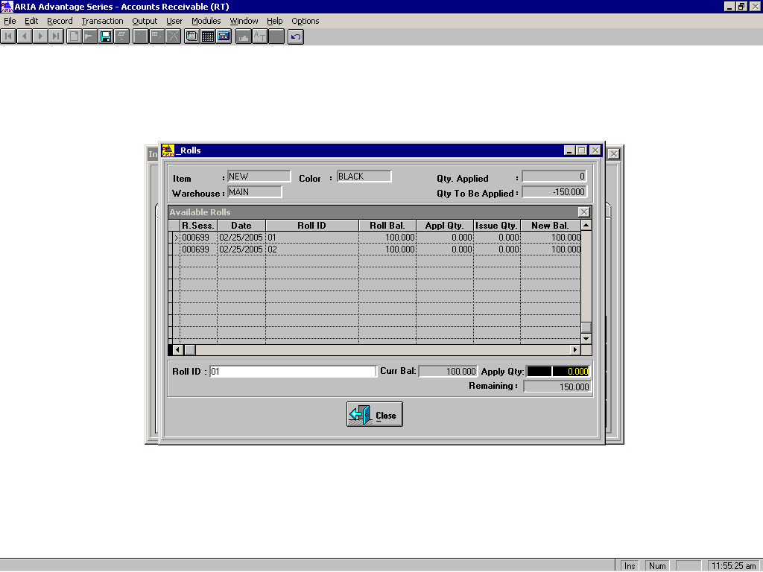
Apply Qty Field
Roll Value

We are using the same interface we are using right now on Aria27. The changes will be related to screen bevaviour only.

UI Rules
The only UI rule that should be mentioned in this specs is related to defaulting the “Apply Qty” when the user clicks with the mouse on the roll line in the browse.

